**3.7 I can select and join networks and data feeds to manage data to suit collaborative tasks**

It is very easy, and in fact sometimes hard to avoid, receiving emails, often in the form of a newsletter or containing offers of some kind, from an organisation offering it. Whenever one orders something online you are often presented with radio boxes to tick or untick to tailor what you receive, or to avoid it. Many times however, especially on websites with fewer options, you are automatically subscribed to a mailing list that you need to actively unsubscribe to, if desired.

You may of course proactively subscribe to a mailing list which you will find interesting or helpful. Myself I am subscribed to a website called *howstuffworks.com* and periodically receive emails from them that look like the below:

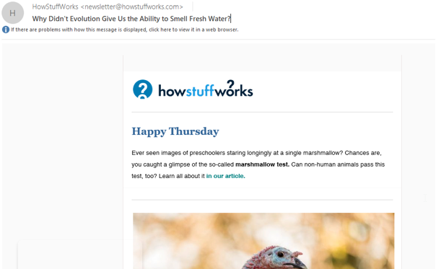

I have also subscribed to several job sites that sent me updates. A convenient option for many mailing lists is that you can vary how often you receive notifications from them, depending on how repetitive or tedious you find them, in a bid to avoid you from taking yourself off their list.

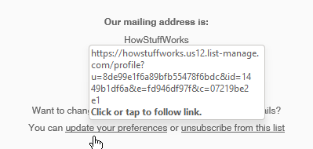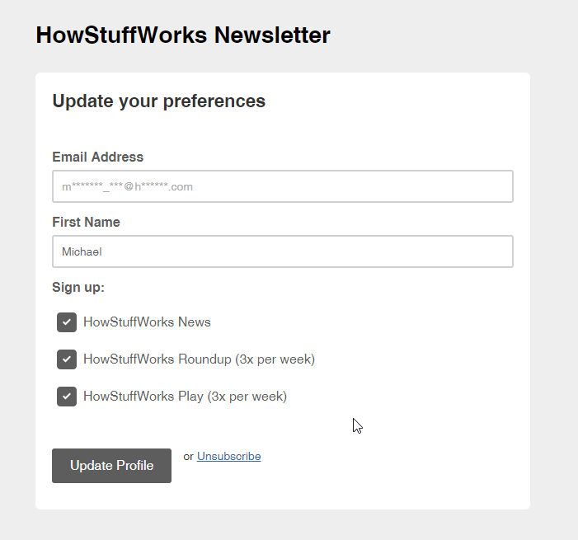

Modern email programs are often also able to block emails coming from a particular sender, if for whatever reason it is not possible to unsubscribe. I have subscribed to relevant networks at my workplace to stay involved with a number of collaborative groups such as for Continuous Improvement/ Mental Health/ Human Resources/ etc.

I would not choose to subscribe to a service via RSS as nowadays very few services offer it, though I appreciate it was common in the past and offered by numerous providers. Far more common now is to either be on a mailing list and receive notifications, or to log into a social networking site like Facebook or Twitter to receive updates.